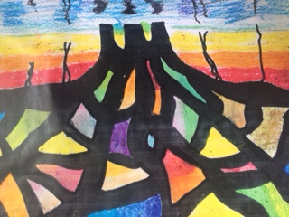
Reflections on Faith
RE & Art Competition
2020 - 2021

WHAT: This is an exciting opportunity for pupils to link RE reflections with art to produce creative work, exploring their ideas and recording their experiences or the experiences of others.
HOW: Entries are invited around the theme of ‘Reflections on Faith’ and could include work on any of the major world faiths. The intention is that this task could fit with any RE unit the children are working on. It could also link with the diocesan understanding of spirituality, reflecting those ‘golden glue’ moments when the ‘ows’, ‘wows’ and ‘nows’ of life crack through everyday normality.
There would also be the possibility of entries reflecting an individual child’s experience. This may be part of the ‘making connections’ stream of an RE unit or may be done in another part of the school timetable, for example following collective worship or linked to prayer spaces events.
Entries must be no larger than A3 (including mounting), must be 2D, must be single or double mounted and can be created using any medium. Each entry needs be accompanied by a BRIEF explanation from the child, explaining what they have created and how it links to their RE learning and understanding. This can be written by the chid or transcribed by an adult and must be clipped to their art work in the label below.
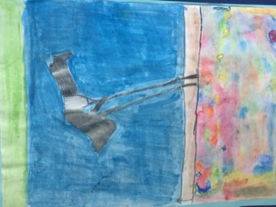
We hope to exhibit all entries but this will be dependent on numbers, there will be multiple prizes. We hope the art will be exhibited at Discover DeCrypt in Gloucester. Further details to follow.
WHO: Entries are welcomed from any primary aged child, from any school or as individual entry, created at home. The entrants name, age, year group and an adult’s telephone contact number must be attached to the back of every picture. Please securely attach a label like the one below to the front of each entry.
WHEN: The art needs to be received by the education department by March 31st 2021. Details of collection points via RE hub leaders and diocesan officers will be available in due course. Prizes and certificates to all participating schools will be delivered during term five.
For any questions about this competition, please contact Debbie Helme dhelme@glosdioc.org.uk
Title of Artwork:
First name of child:
School year of child:
Explanation of work:

