Glimpses of Belief
RE & Art Competition
2021 - 2022
WHAT: Following from the success of previous years, it is now possible to enter this year’s RE & Art competition, ‘Glimpses of Belief’. This is an exciting opportunity for pupils to link insights in RE with art to produce creative work, exploring their ideas and recording their experiences or the experiences of others.
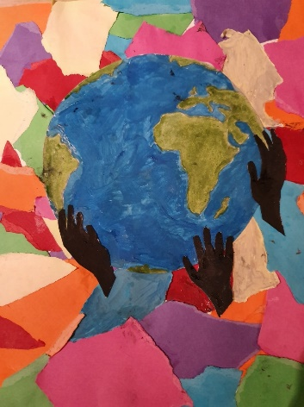
HOW: Entries are invited around this theme of ‘Glimpses of Belief’ and could include work on any of the major world faiths. The intention is that this task could fit with any RE unit the children are working on. It could also link with the diocesan understanding of spirituality, reflecting those ‘golden glue’ moments when the ‘ows’, ‘wows’ and ‘nows’ of life crack through everyday normality.
There would also be the possibility of entries reflecting an individual child’s experience. This may be part of the ‘making connections’ stream of an RE unit or may be done in another part of the school timetable, for example following collective worship or linked to prayer spaces events.
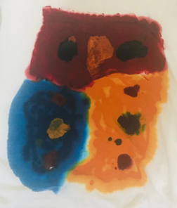
This year, to make things as simple as possible, we will only be receiving entries sent electronically. Any medium or any sized work can be produced but it will need to be photographed or scanned. Each entry also needs be accompanied by a BRIEF explanation from the child, explaining what they have created and how it links to their RE learning and understanding. This can be written by the chid or transcribed by an adult and must be sent with their art work – see the suggested form below.
WHO: Entries are welcomed from any primary aged child, from any school and can be created at home. The entrants first name, year group and school must be included.
WHEN: The art needs to be received by Debbie Helme at education@glosdioc.org.uk by April 8 2022.
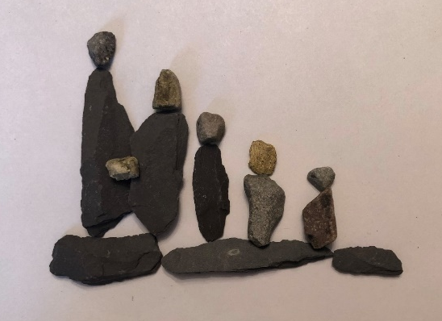
Title of Artwork:
School:
First name of child:
School year of child:
Explanation of work:

